ECA3101-NANO ELECTRONICS
Exp. 1. Simulation of scattering and absorption of Multi-layer Sphere and Core-Shell Nanoparticle using Mie-Plot tool
TEST CASE-1: Scattering and absorption spectra for a single-layer sphere
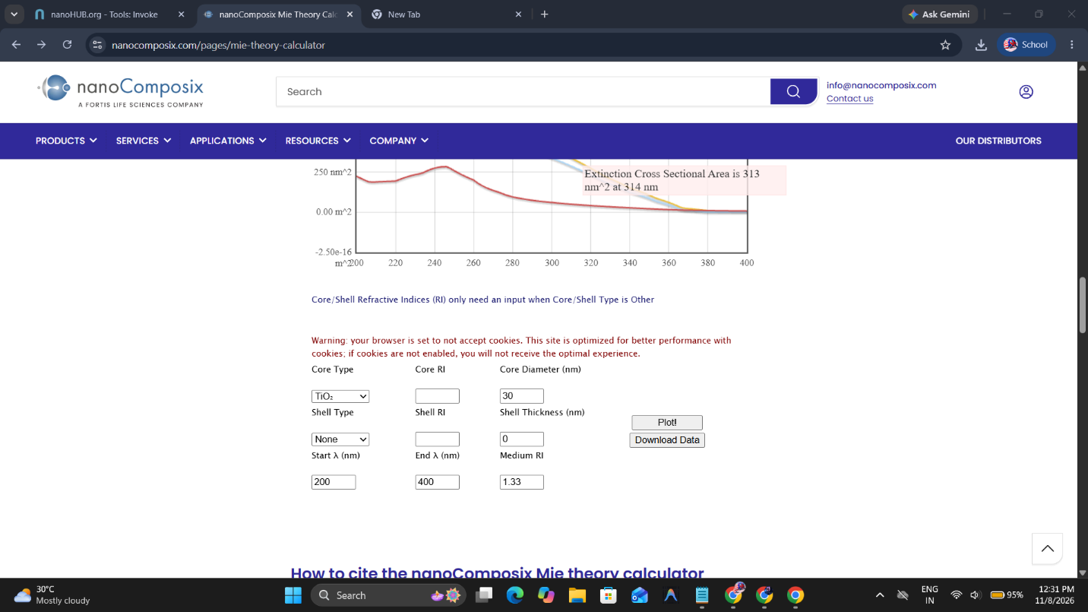
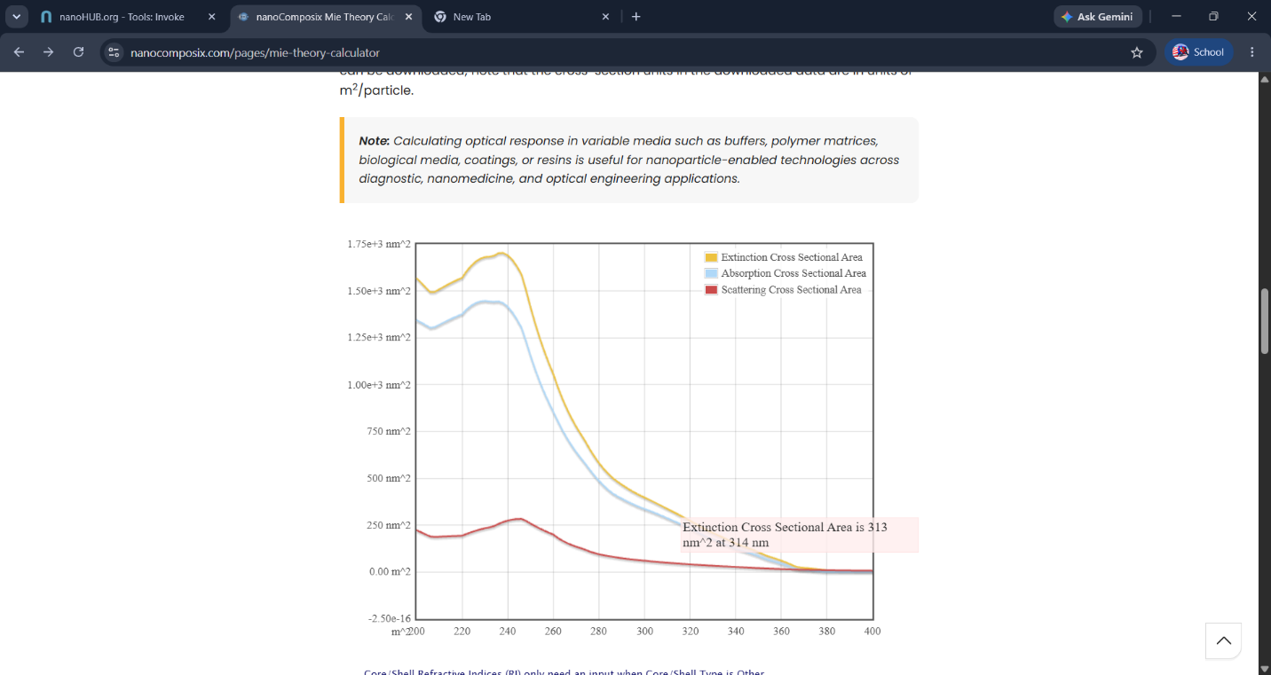

TEST CASE-2: optical response of a gold (Au) nanoparticle of 50 nm diameter
in water medium. 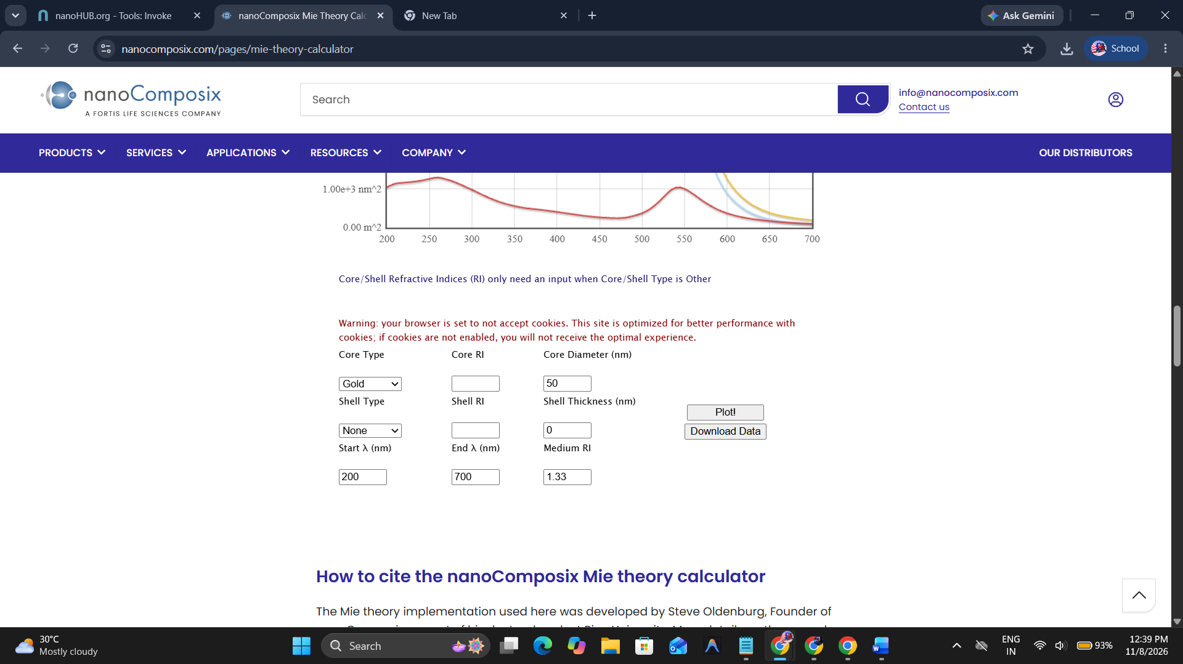
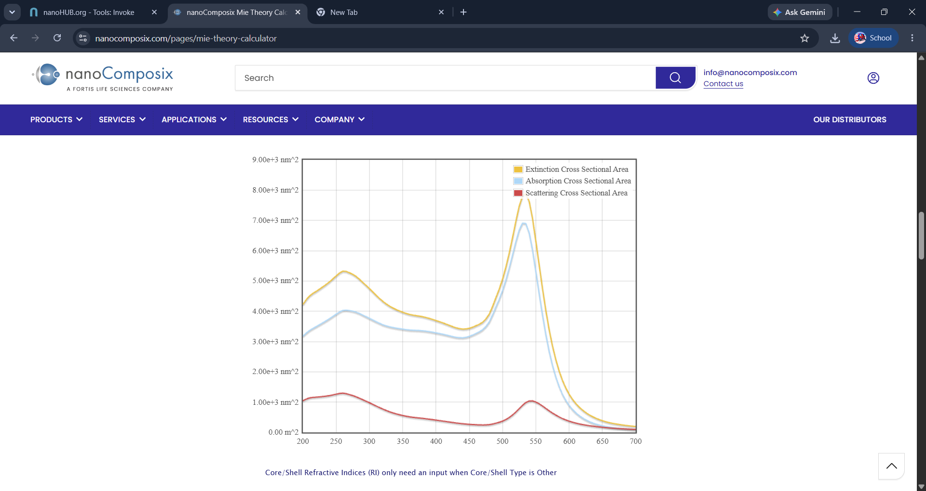

TEST CASE-3: core–shell nanoparticle with a gold core (30 nm) and silica shell
(10 nm).


